**Objective 3:**

* Write a program to find sum of digits of a given number & reverse of number .
* Write a program to check palindrome or not .
* Check a number is Armstrong or not .
* Count no of digits of a number.
* Factorial of a number .
* Table of a number and limit entered by the user.
* Check no is prime or not.
* Find Fibonacci series and its sum .

Answer:

code:

number=eval(input("enter the number to get the reverse of it :"))

sum =0

sum1=0

while number>0:

rem=number%10

sum=sum*10+rem

sum1=sum1+rem

number=number//10

print("reverse of number is :",sum)

print("sum of digit :",sum1)

output:

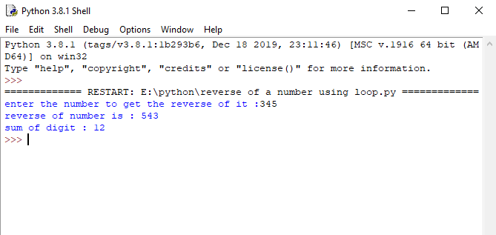

2.code:

n=eval(input("Enter the number to check no palindrome :"))

k=n

sum=0;

while k>0:

rem=k%10

sum = sum*10 + rem

k=k//10

if sum==n:

print(sum ," is palindrome :")

else:

print( sum," is not palindrome ")

output:

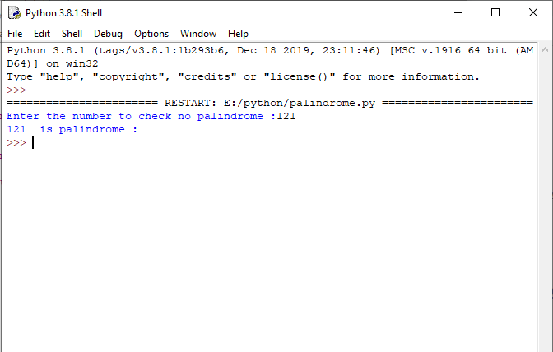

3.Code:

low=eval(input("enter the lower limit"))

high=eval(input("enter the upper limit"))

print("palindrome no in range" , low," and ", high, " is :")

for i in range(low , high+1) :

x = i

count= 0

while (x != 0) :

x = x // 10

count= count + 1

sum = 0

x = i

while (x != 0) :

digit = x % 10

sum = sum + pow(digit, count)

x = x //10

if (sum == i) :

print(sum ," "),

output:

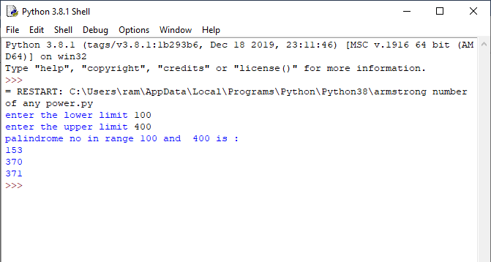

4.

code:

n=eval(input("Enter the number for table :"))

rang=eval(input("Enter the range of table :"))

sum=0

for i in range(0,rang+1):

sum=n*i

print(n,"*",i,"=",sum)

output:

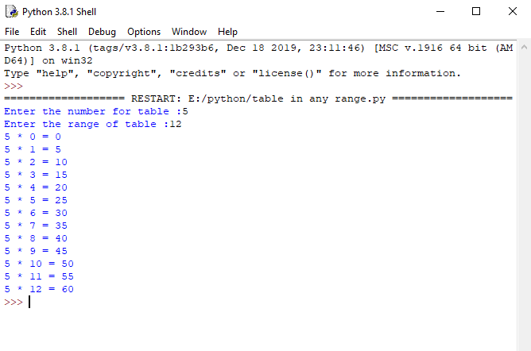

5.

Code:

n=eval(input("enter the check is prime or not :"))

temp=0

for i in range(2,n//2+1):

if(n%i==0):

temp=1

if(temp==1):

print(n," is not prime")

else:

print(n," is prime")

output:

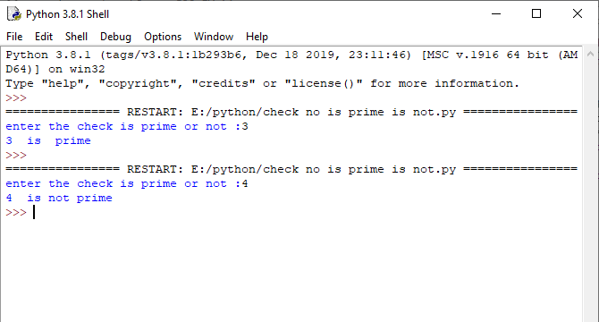

6.Code:

n=eval(input("enter the no of digit "))

a=0

b=1

c=0

sum=0

sum= sum+a++b+c

print(a,end=" ")

for i in range(0,n-1):

a=b

b=c

c=a+b

sum=sum+c

print(c,end=" ")

print("\n sum=",sum)

output:

